N-gonal Antiprism
# Source: AI Source: Provided by: [Data Path: Persons Table -> ID Column: 1, Name_En Column: Motasem Essam] -> From: [ChatGPT] on [7/25/2026]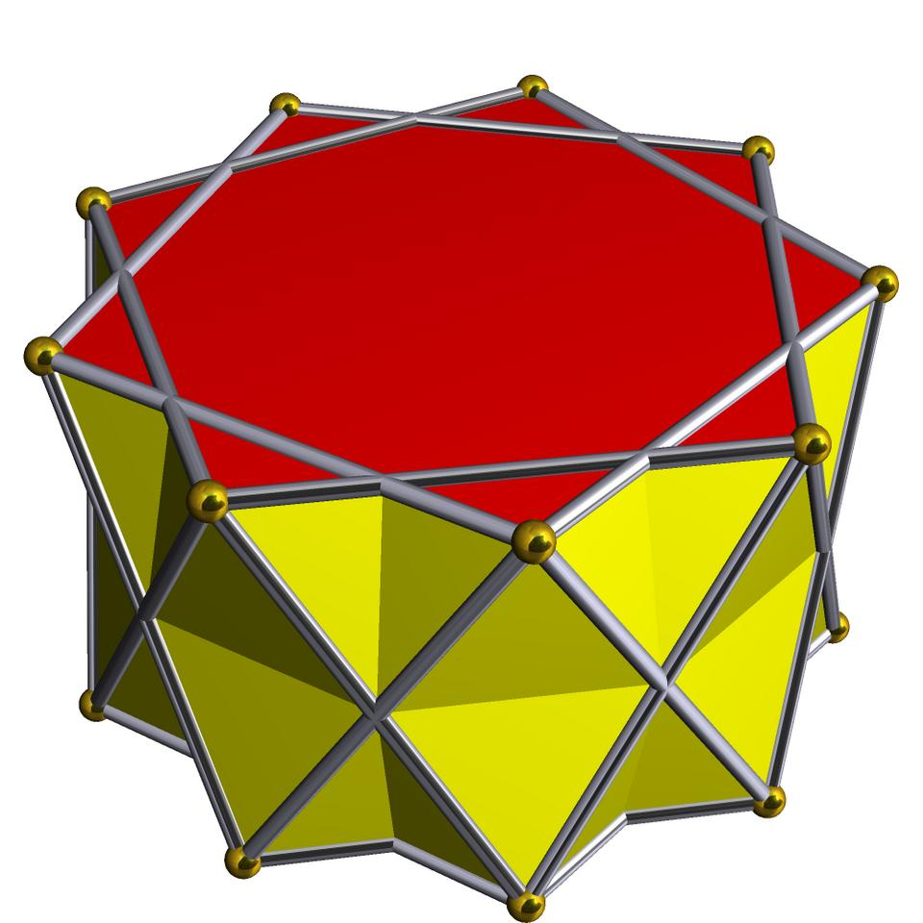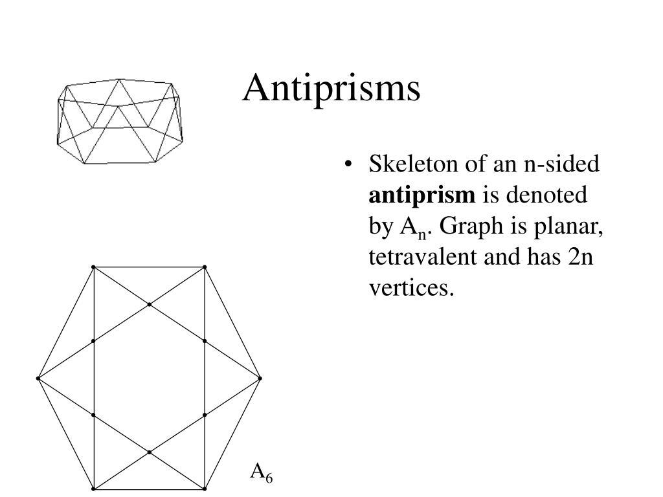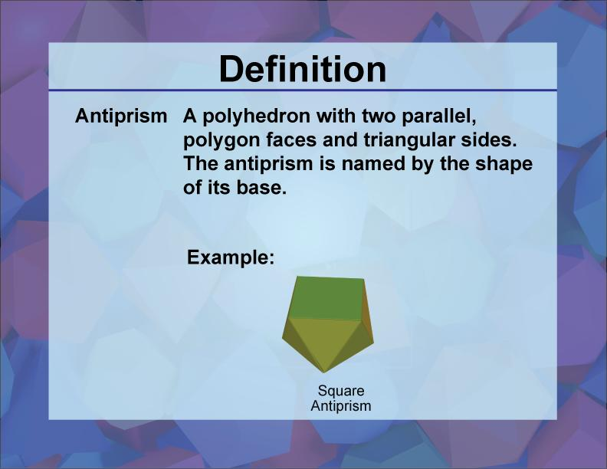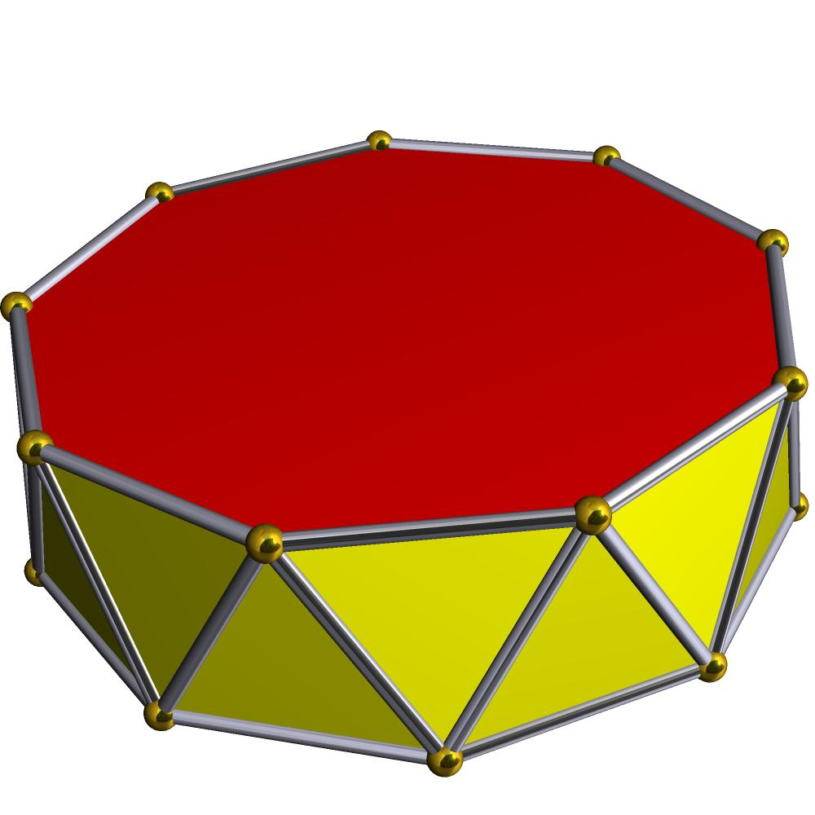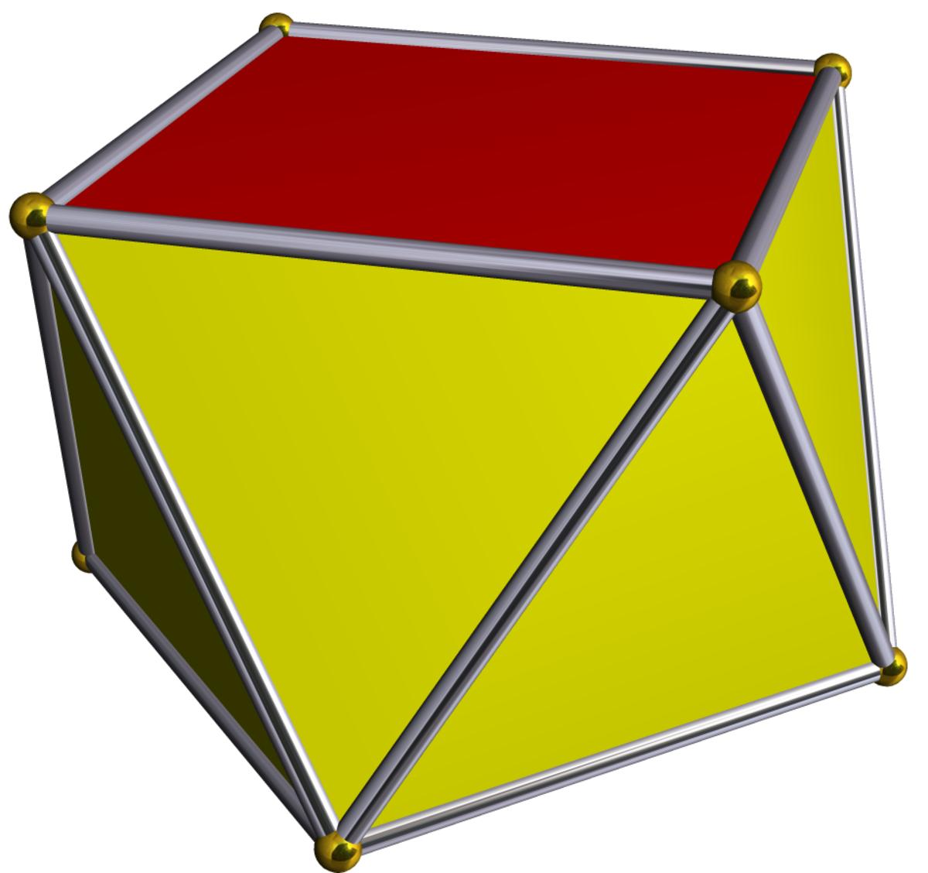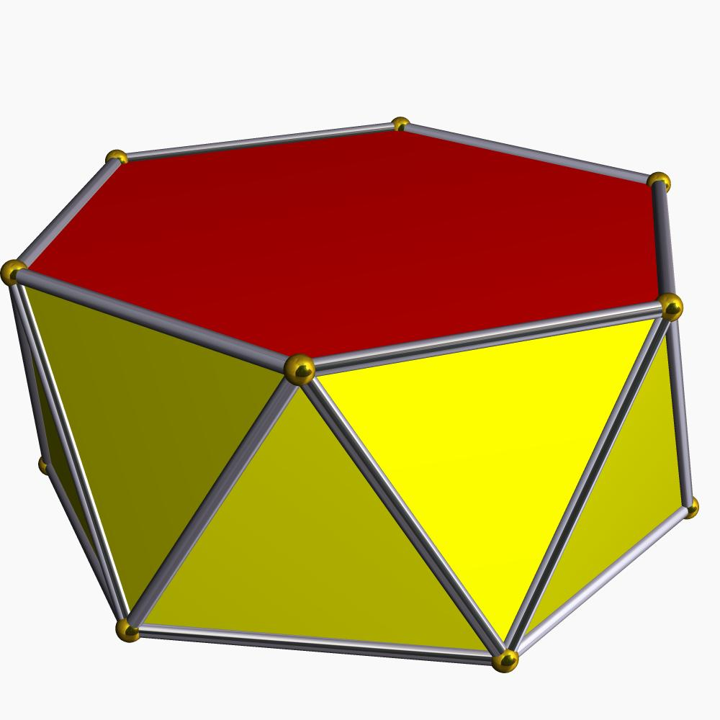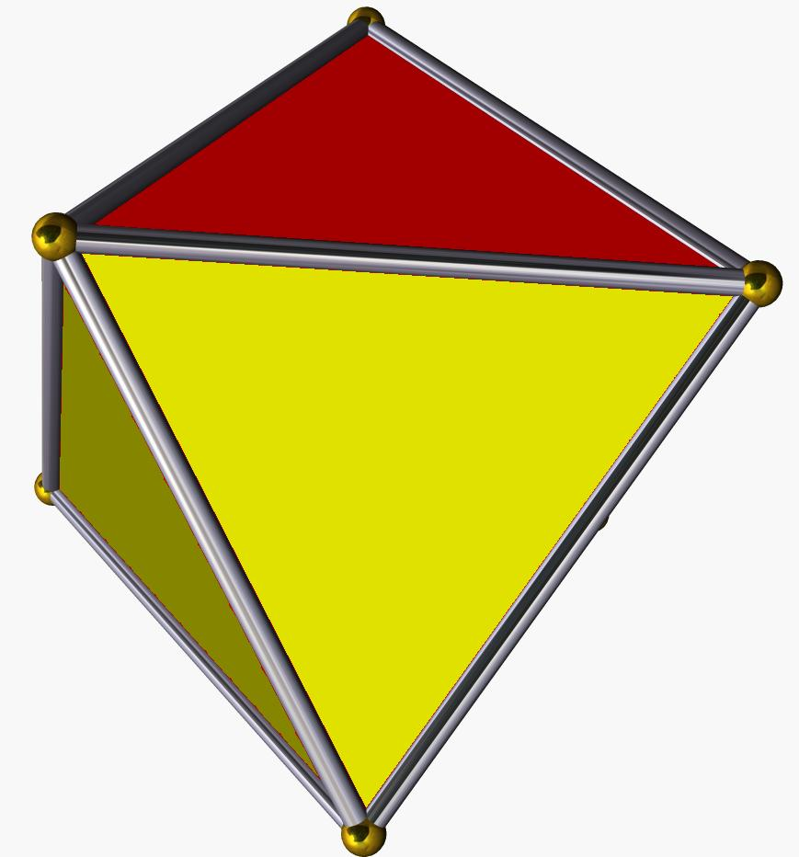

Definition
# Source: AI Source: Provided by: [Data Path: Persons Table -> ID Column: 1, Name_En Column: Motasem Essam] -> From: [ChatGPT] on [7/25/2026]
An n-gonal Antiprism is a polyhedron consisting of two parallel, congruent regular $n$-sided polygonal bases, with one base rotated relative to the other. The two bases are connected by $2n$ triangular lateral faces.
It is a general type of antiprism whose base polygons can have any number of sides $n$, where $n≥3$.

Geometric Structure
# Source: AI Source: Provided by: [Data Path: Persons Table -> ID Column: 1, Name_En Column: Motasem Essam] -> From: [ChatGPT] on [7/25/2026]
An n-gonal antiprism consists of:
- Upper n-gonal Base: A regular polygon with $n$ sides forming the top face.
- Lower n-gonal Base: A congruent regular polygon forming the bottom face, rotated relative to the upper base.
- Triangular Lateral Faces: $2n$ triangles connecting the two polygonal bases.
- Vertices: $2n$ vertices, with $n$ on each base.
- Edges: $4n$ edges connecting the vertices.

Face Composition
# Source: AI Source: Provided by: [Data Path: Persons Table -> ID Column: 1, Name_En Column: Motasem Essam] -> From: [ChatGPT] on [7/25/2026]
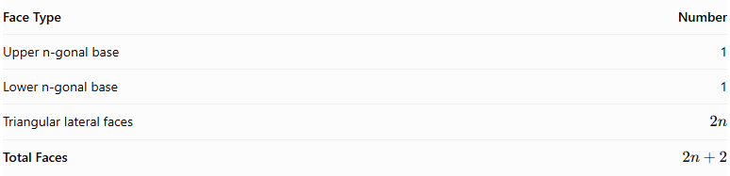
Face Type | Number
Upper n-gonal base | 1
Lower n-gonal base | 1
Triangular lateral faces | $$2n$$
Total Faces | $$2n+2$$

Mathematical Properties
# Source: AI Source: Provided by: [Data Path: Persons Table -> ID Column: 1, Name_En Column: Motasem Essam] -> From: [ChatGPT] on [7/25/2026]
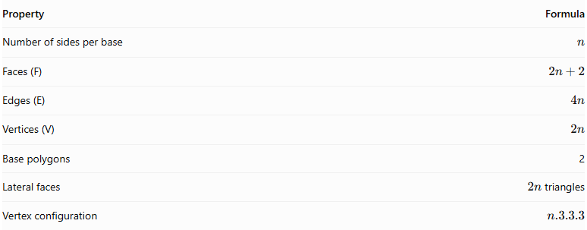
Property | Formula
Number of sides per base | $$n$$
Faces (F) | $$2n+2$$
Edges (E) | $$4n$$
Vertices (V) | $$2n$$
Base polygons | 2
Lateral faces | $2n$ triangles
Vertex configuration | $$n.3.3.3$$
Euler's formula:
$$V-E+F=2$$
Substituting the general formulas:
$$2n-4n+(2n+2)=2$$
Regular n-gonal Antiprism
In a regular n-gonal antiprism:
- Both bases are regular and congruent $n$-gons.
- The upper and lower bases are rotated relative to each other, typically by half the central angle between consecutive vertices:
$$θ=\frac{{180}^{∘}}{n}$$
- All $2n$ lateral triangular faces are equilateral.
- The vertices have the same local arrangement.
- The solid has rotational symmetry around its central axis.

Examples of n-gonal Antiprisms
# Source: AI Source: Provided by: [Data Path: Persons Table -> ID Column: 1, Name_En Column: Motasem Essam] -> From: [ChatGPT] on [7/25/2026]
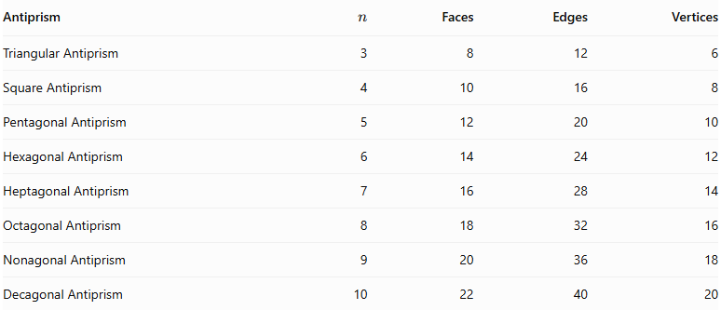
Antiprism | $$n$$ | Faces | Edges | Vertices
Triangular Antiprism | 3 | 8 | 12 | 6
Square Antiprism | 4 | 10 | 16 | 8
Pentagonal Antiprism | 5 | 12 | 20 | 10
Hexagonal Antiprism | 6 | 14 | 24 | 12
Heptagonal Antiprism | 7 | 16 | 28 | 14
Octagonal Antiprism | 8 | 18 | 32 | 16
Nonagonal Antiprism | 9 | 20 | 36 | 18
Decagonal Antiprism | 10 | 22 | 40 | 20

Constructing N-gonal Antiprism in Solid Geometry

Geometric Instruments Used
# Source: AI Source: Provided by: [Data Path: Persons Table -> ID Column: 1, Name_En Column: Motasem Essam] -> From: [ChatGPT] on [7/25/2026]
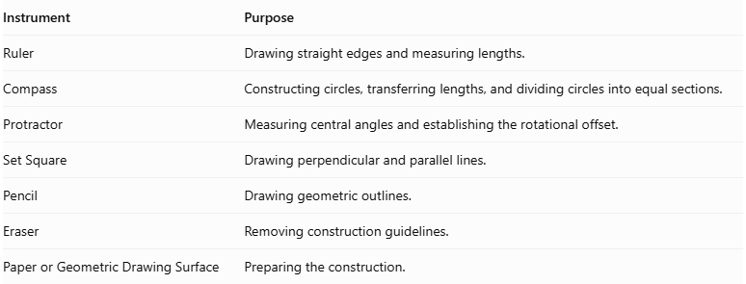
Instrument | Purpose
Ruler | Drawing straight edges and measuring lengths.
Compass | Constructing circles, transferring lengths, and dividing circles into equal sections.
Protractor | Measuring central angles and establishing the rotational offset.
Set Square | Drawing perpendicular and parallel lines.
Pencil | Drawing geometric outlines.
Eraser | Removing construction guidelines.
Paper or Geometric Drawing Surface | Preparing the construction.

Instrument-Based Construction Procedures
# Source: AI Source: Provided by: [Data Path: Persons Table -> ID Column: 1, Name_En Column: Motasem Essam] -> From: [ChatGPT] on [7/25/2026]
The $n$-gonal antiprism can be constructed using geometric instruments and classical geometric drawing techniques, without using coordinate-based construction.

Determining the Polygonal Base
# Source: AI Source: Provided by: [Data Path: Persons Table -> ID Column: 1, Name_En Column: Motasem Essam] -> From: [ChatGPT] on [7/25/2026]
- Select the number of sides $n$ for the polygonal bases.
- Determine the central angle using:
$$θ=\frac{{360}^{°}}{n}$$
- Draw a circle using a compass.
- Divide the circle into $n$ equal angular sections using a protractor.
- Mark the vertices on the circumference.
- Connect consecutive vertices using a ruler to form a regular $n$-gon.
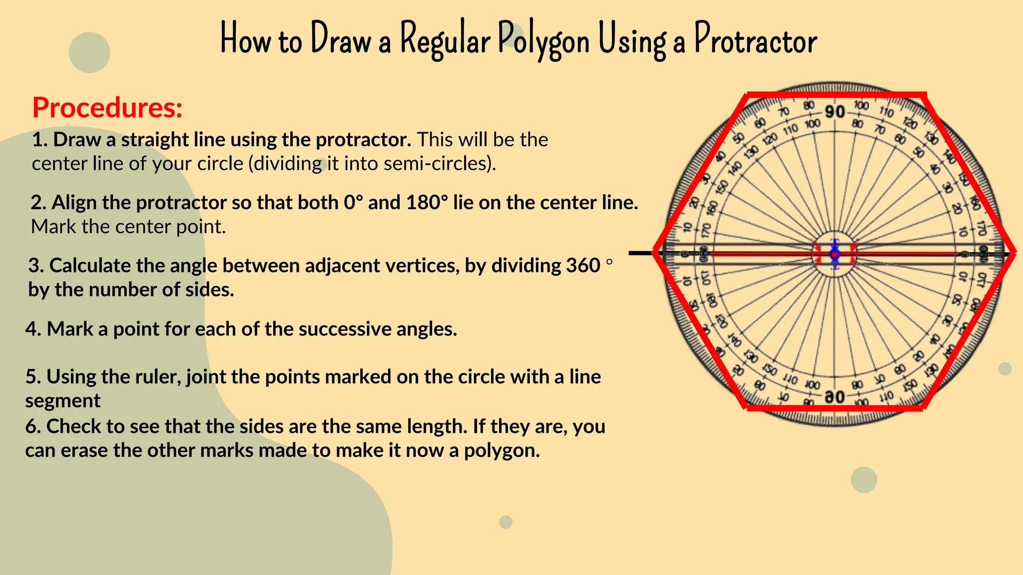

Constructing the Upper Polygonal Base
# Source: AI Source: Provided by: [Data Path: Persons Table -> ID Column: 1, Name_En Column: Motasem Essam] -> From: [ChatGPT] on [7/25/2026]
- Draw a second regular $n$-gon congruent to the lower base.
- Position it above and parallel to the lower polygon.
- Rotate its orientation by half the central angle:
$$α=\frac{{180}^{°}}{n}$$
- Maintain the same side length and geometric proportions.
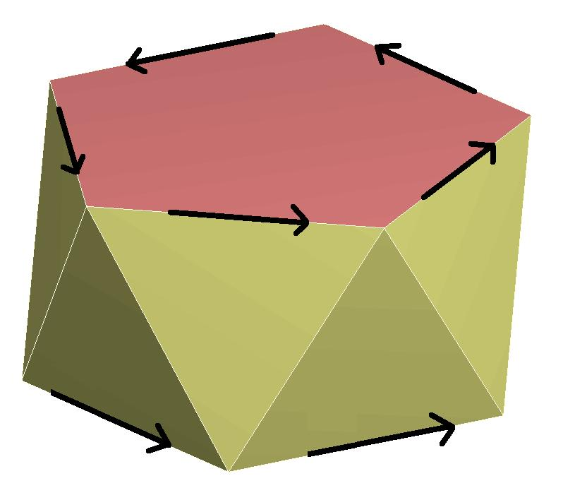

Connecting the Two Bases
# Source: AI Source: Provided by: [Data Path: Persons Table -> ID Column: 1, Name_En Column: Motasem Essam] -> From: [ChatGPT] on [7/25/2026]
- Connect each vertex of the lower polygon to the two nearest vertices of the upper polygon.
- Repeat the connections around the entire solid.
- Ensure that the connecting edges alternate between the upper and lower bases.
- Form $2n$ triangular lateral faces.
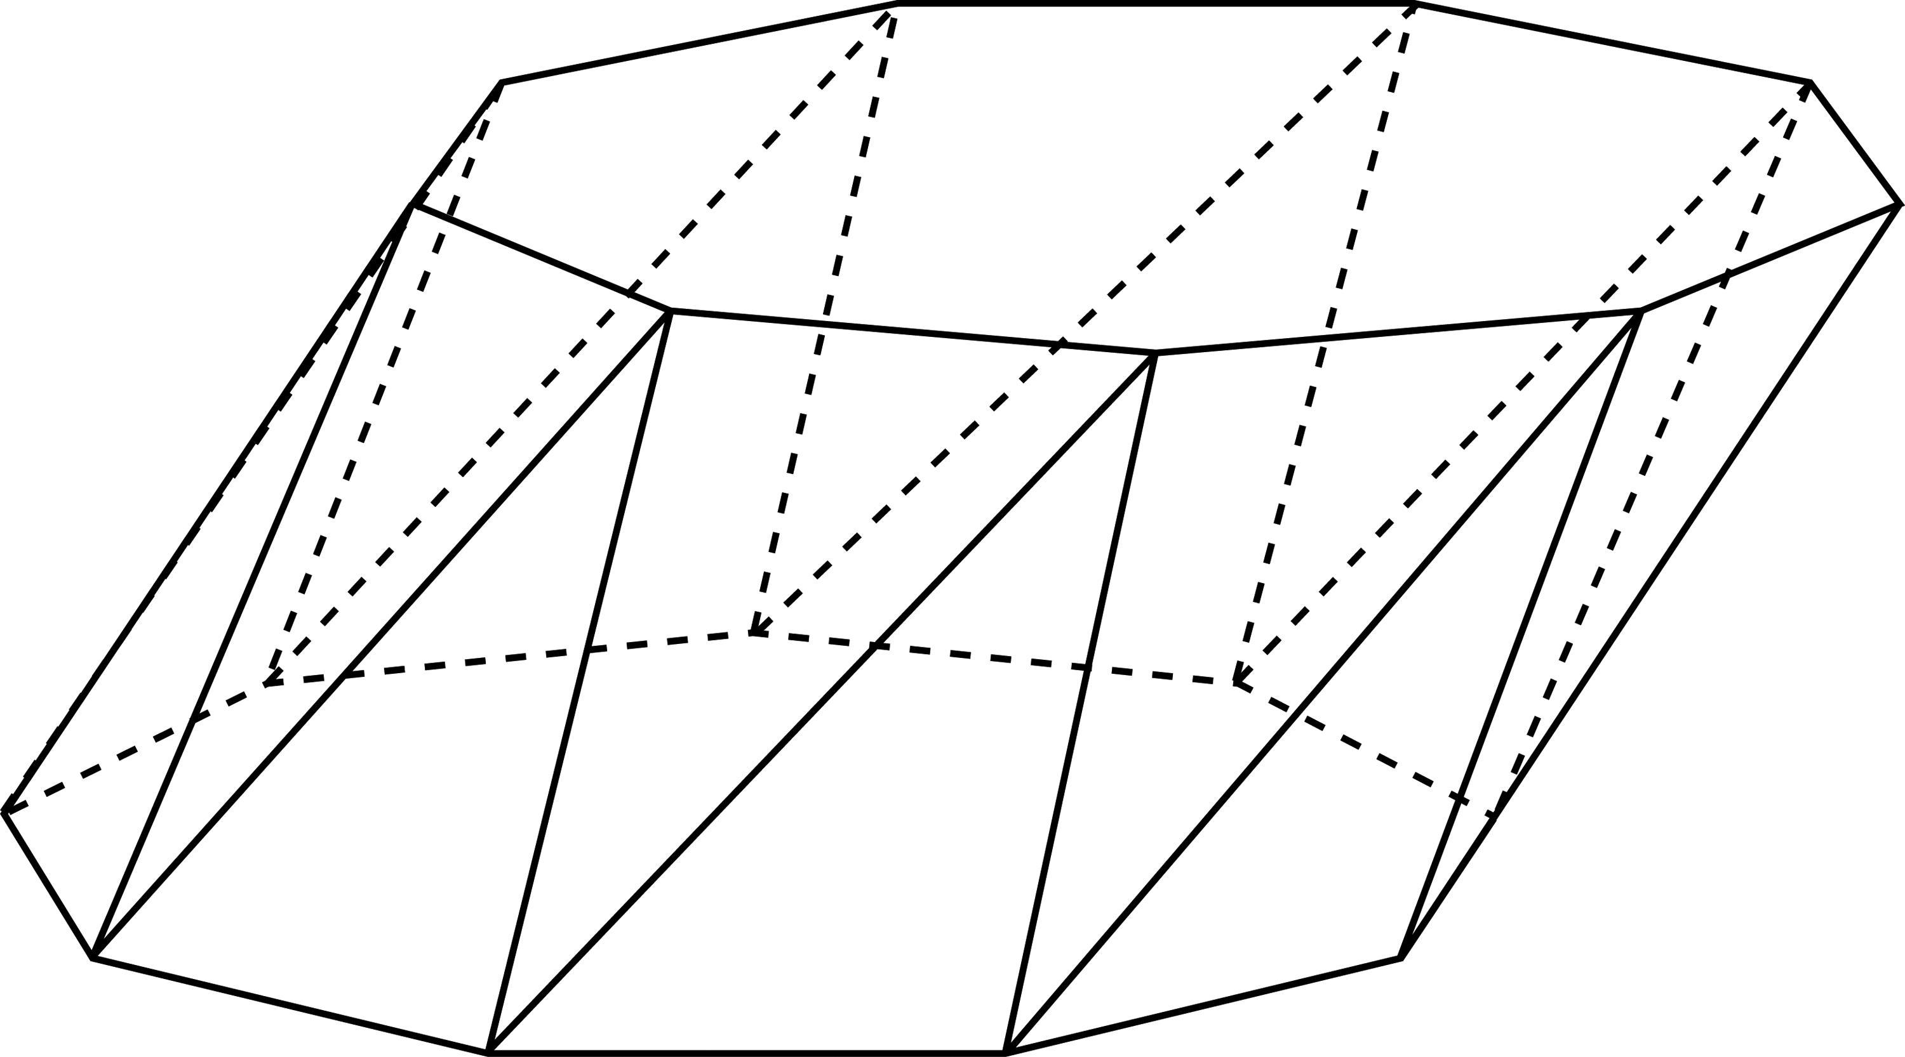

Completing the Solid
# Source: AI Source: Provided by: [Data Path: Persons Table -> ID Column: 1, Name_En Column: Motasem Essam] -> From: [ChatGPT] on [7/25/2026]
- Complete all $2n$ triangular lateral faces.
- Emphasize the visible edges.
- Use dashed lines for hidden edges when necessary.
- Verify that both polygonal bases are congruent and parallel.
- Check that the upper base has the correct rotational offset.
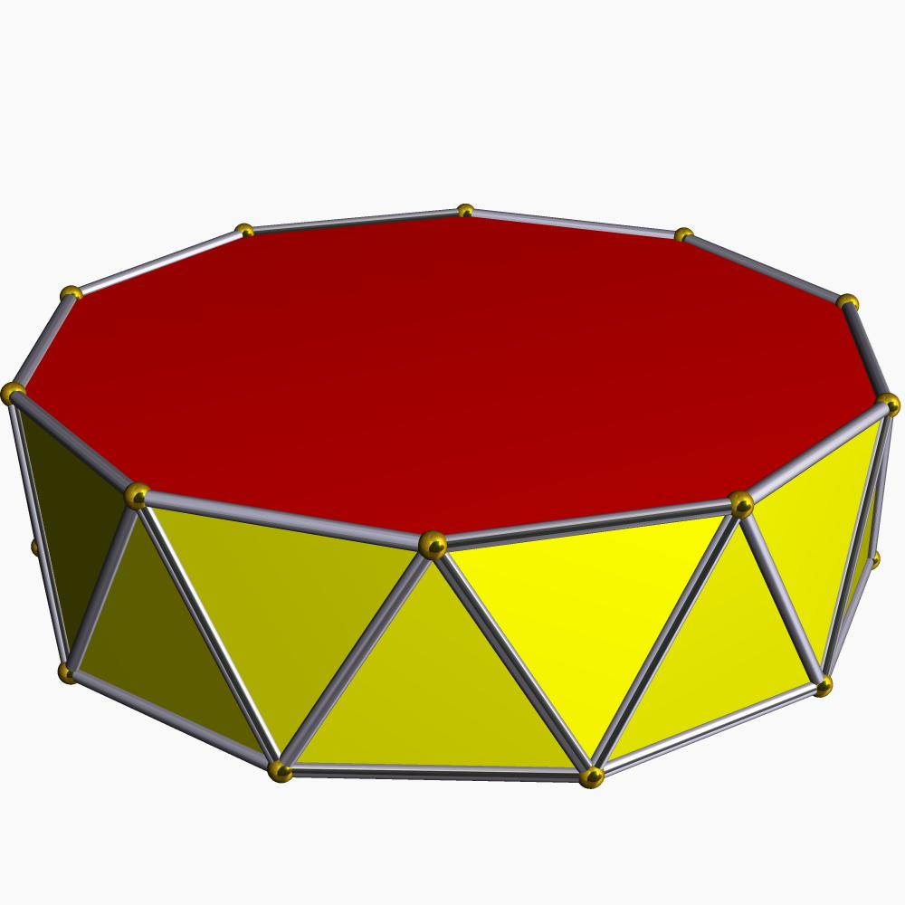

Constructing a Net
# Source: AI Source: Provided by: [Data Path: Persons Table -> ID Column: 1, Name_En Column: Motasem Essam] -> From: [ChatGPT] on [7/25/2026]
A net of an $n$-gonal antiprism contains:
- Two congruent $n$-gonal bases.
- $2n$ triangular lateral faces.
- A connected arrangement of faces with matching edge lengths and correct face adjacency.
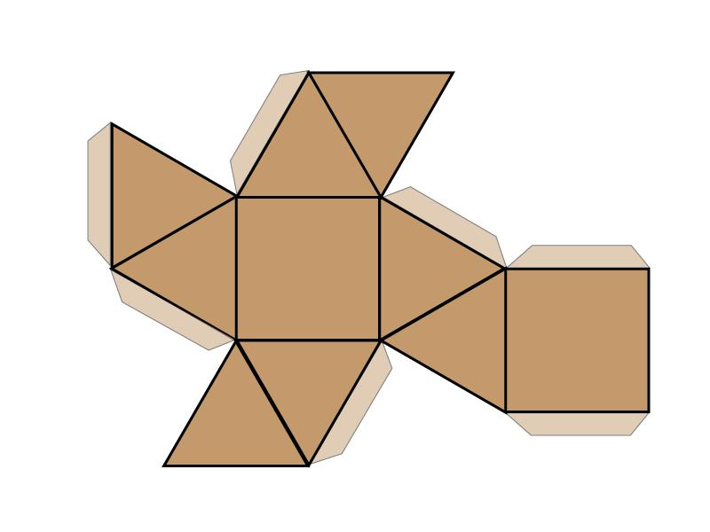

Key Points
# Source: AI Source: Provided by: [Data Path: Persons Table -> ID Column: 1, Name_En Column: Motasem Essam] -> From: [ChatGPT] on [7/25/2026]
- It has two parallel, congruent polygonal bases.
- The bases are rotated relative to each other.
- Each base has $n$ sides.
- It has $2n$ triangular lateral faces.
- It contains $2n+2$ faces, $4n$ edges, and $2n$ vertices.
- The triangular antiprism is a special case of the n-gonal antiprism when $n=3$.

Classification
# Source: AI Source: Provided by: [Data Path: Persons Table -> ID Column: 1, Name_En Column: Motasem Essam] -> From: [ChatGPT] on [7/25/2026]
Solid Geometry
└── Types of Solids
└── Antiprism
└── Types of Antiprisms
├── Triangular Antiprism
├── Square Antiprism
├── Pentagonal Antiprism
├── Hexagonal Antiprism
├── Heptagonal Antiprism
├── Octagonal Antiprism
├── Nonagonal Antiprism
├── Decagonal Antiprism
└── n-gonal Antiprism

Conclusion
# Source: AI Source: Provided by: [Data Path: Persons Table -> ID Column: 1, Name_En Column: Motasem Essam] -> From: [ChatGPT] on [7/25/2026]
An n-gonal Antiprism is a general antiprism with two congruent $n$-sided polygonal bases and $2n$ triangular lateral faces. Its structure follows the general formulas $F=2n+2$, $E=4n$, and $V=2n$.

